Computer Language Coding Concepts

Command Calls in an Active Clause in a Diagram
Command calls in an active clause have been conceptually explained in the article Command Calls in an Active Clause.

This article only illustrates how command calls in an active clause look in a diagram.

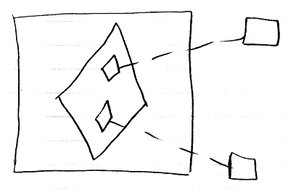

The large square is the command definition the clause is in. The diamond inside of it, is the active clause. It contains two diamonds, which are the command calls inside the active clause. The small diamonds redirect their command definition with a class line, a dashed line, connected to the squares on the right, which are the command definitions, that are called.

The creation behavior of command calls in an active clause will not be further explained with diagrams in this article. Refer to the article Creation Behavior of Command Callls in a Diagram for an illustration of how the creation behavior of command calls looks in a diagram.

See also: Command Calls in an Active Clause,
Creation Behavior of Command Calls in a Diagram

Author & Copyright: Jan-Joost van Zon Date: August 9, 2008 – August 9, 2008 Location: Oosterhout, The Netherlands Status: Under Construction | Finished

